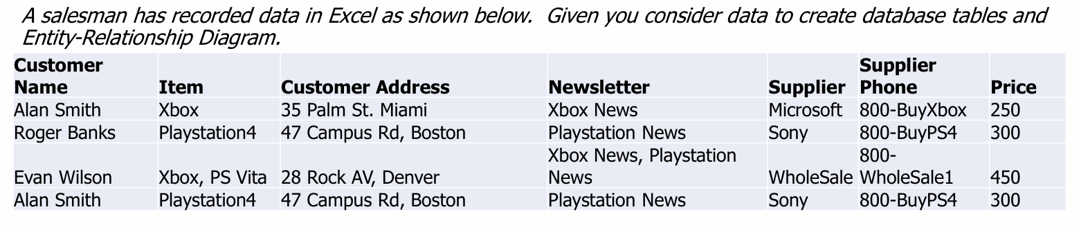
ER Diagram
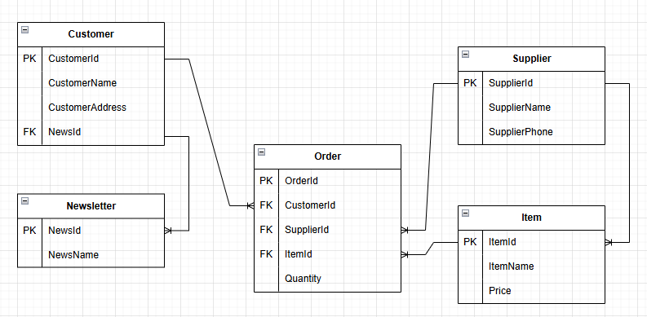
Database Table
Table | Attribute
Customer | CustomerId(PK), CustomerName, CustomerAddress, NewsId
Newsletter | NewsId(PK), NewsName
Supplier | SupplierId(PK), SupplierName, SupplierPhone
Item | ItemId(PK), ItemName, Price
Order | OrderId(PK), CustomerId(FK), SupplierId(FK), ItemId(FK), Quantity

